4. Implement Classification Model Using KNN and Compute Evaluation Metrics
Aim:
To implement a K-Nearest Neighbors (KNN) classification model using Python and evaluate its performance using accuracy, precision, recall, and F1-score
Algorithm:
- Start the program.
- Import the required libraries from Scikit-learn.
- Create a dataset containing input features and target labels.
- Split the dataset into training and testing sets.
- Create a KNN classification model with \(K=3\).
- Train the model using the training data.
- Predict the output for the testing data.
- Calculate accuracy, precision, recall, and F1-score.
- Display the evaluation metrics.
- Stop the program.
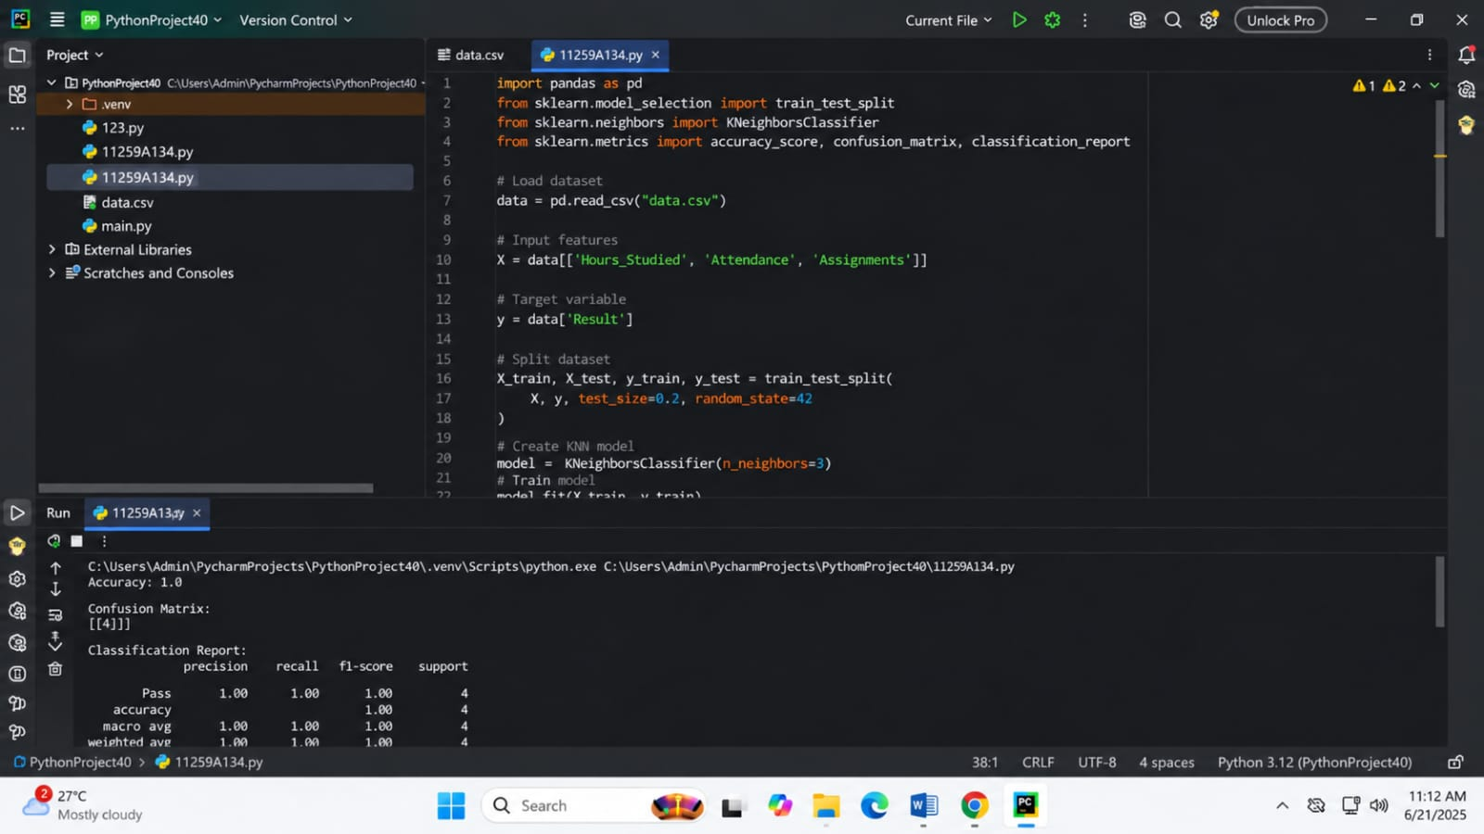
CODE AND OUTPUT:

Result:
Thus, the KNN classification model was successfully implemented using Python, and its performance was evaluated using accuracy, precision, recall, and F1-score.

5. Implement Classification Model Using SVM and Compute Evaluation Metrics

Aim:
To implement a Support Vector Machine (SVM) classification model using Python and evaluate its performance using accuracy, precision, recall, and F1-score.

Algorithm:
- Start the program.
- Import the required libraries from Scikit-learn.
- Create a dataset containing input features and target labels.
- Split the dataset into training and testing sets.
- Create an SVM classification model.
- Train the model using the training data.
- Predict the output for the testing data.
- Calculate accuracy, precision, recall, and F1-score.
- Display the evaluation metrics.
- Stop the program.

CODE AND OUTPUT:

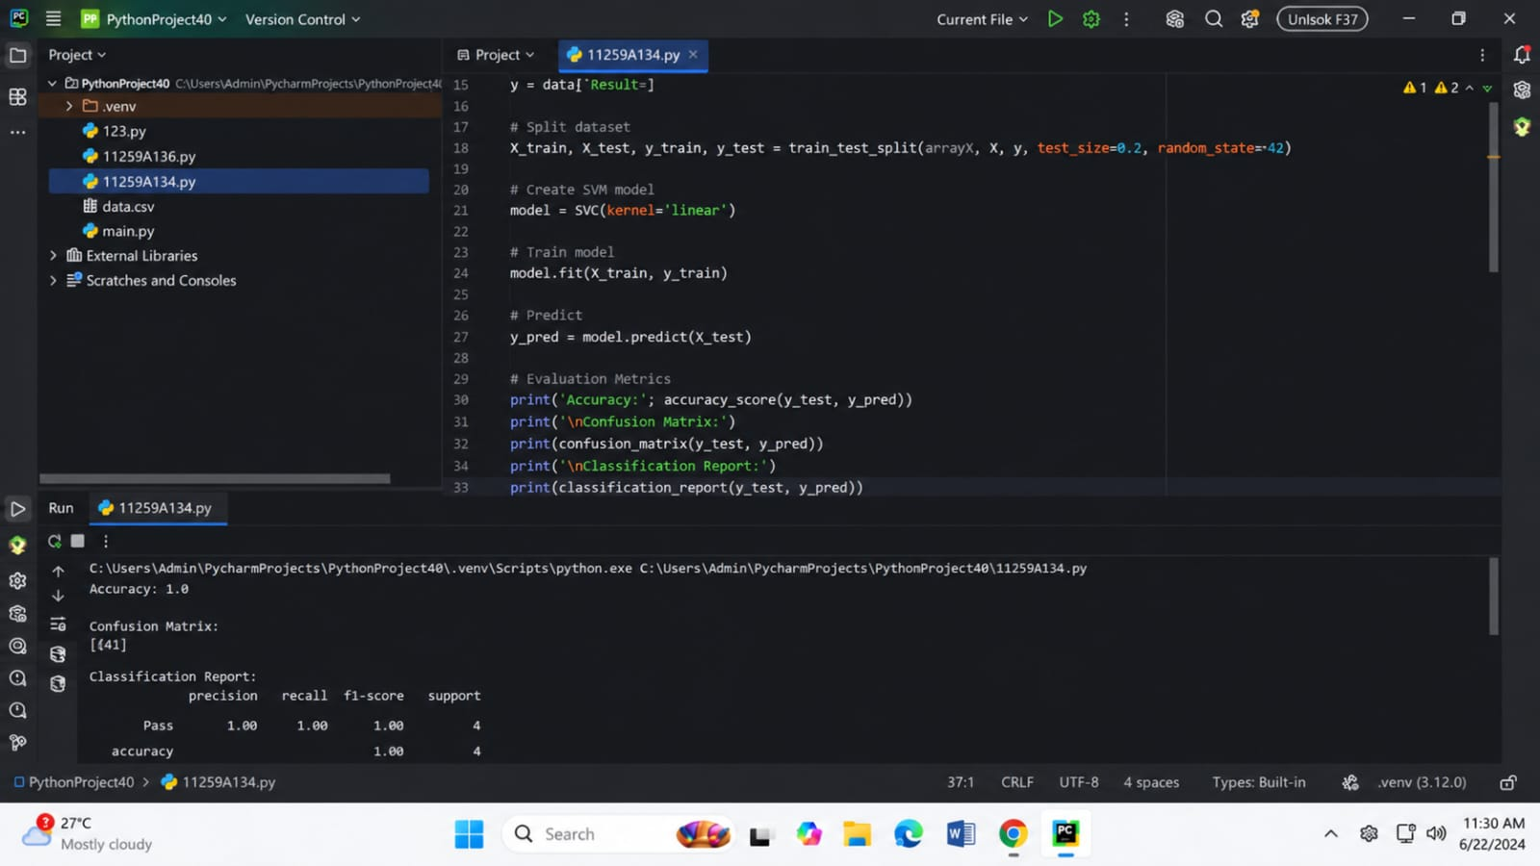
Result:
Thus, the SVM classification model was successfully implemented using Python, and its performance was evaluated using accuracy, precision, recall, and F1-score.

